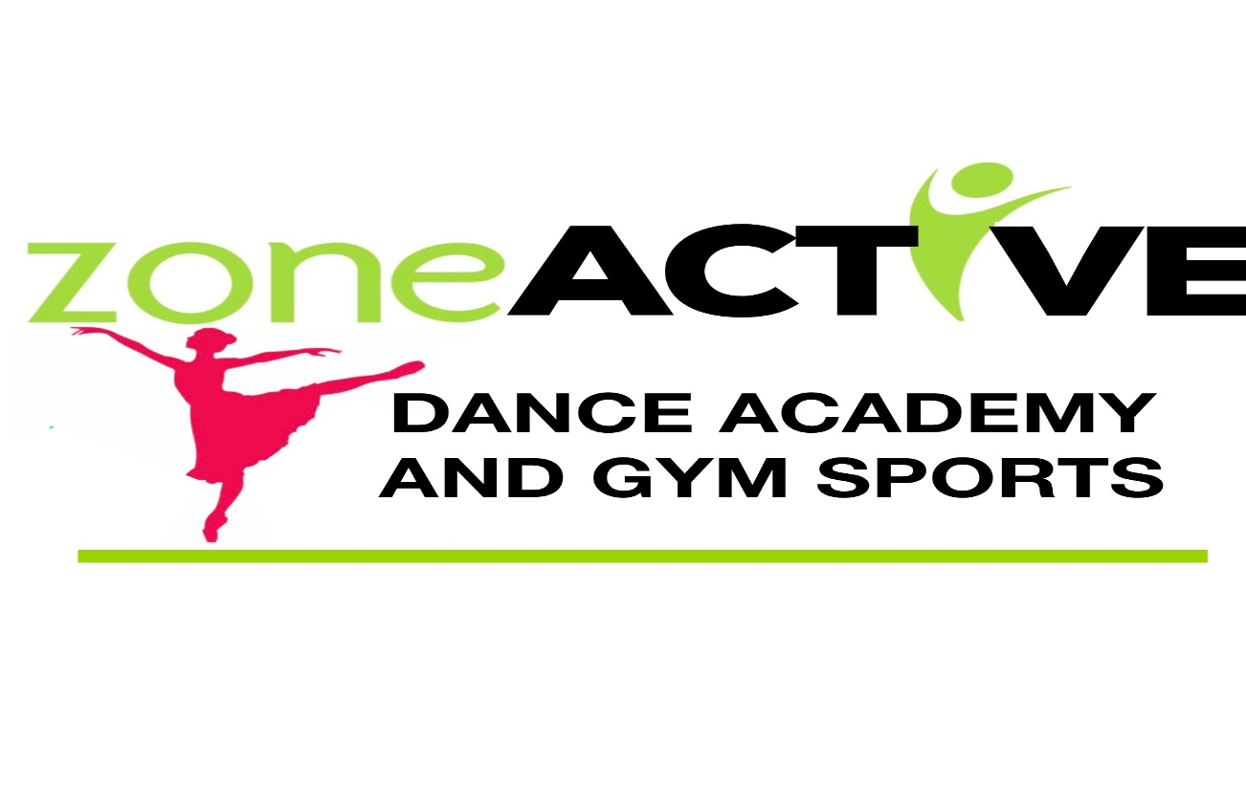
Studio Handbook 2023
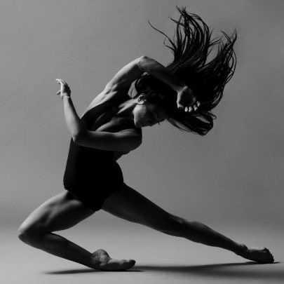

Classes we offer at Zone Active Dance Academy & Gym Sports

CLASSICAL BALLET
JAZZ
TAP
CONTEMPORARY
MUSICAL THEATRE
HIP HOP
COMPETITION TROUPES
EXAM CLASSES
PRIVATE LESSONS
AERIAL SILKS
ACROBATIC ARTS
GYMNASTICS
TRAMPOLINE & TUMBLE
KINDYGYM
TINY TOES PREDANCE/ ACRO

We are affiliated with and use the following syllabus Gymnastics NSW, B.A.L, Tap n Beats & Acrobatic Arts.

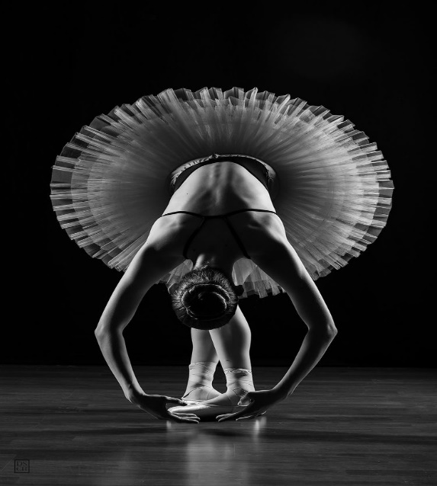

Our mission at Zone Active is to inspire each & every student to be the best possible version of themselves in and out of the studio.
Our focus is on creating a safe, positive environment with a family friendly atmosphere in which our students will have loads of fun whilst learning fundamental fine and gross motor skills, co-ordination, confidence, and a passion for movement
From the tiniest of toes to pre professional adults, just for fun to elite competitions, experience the difference here at Zone Active.

Code of Conduct:
At Zone Active we foster an attitude of acceptance of anyone who wishes to learn.
We expect everyone to work together as a team and create an atmosphere here where everyone will feel included and know that they have something to offer.
In our classes we aim for a high level of energy & enjoyment and aim to develop a love of Dance & a passion for Gym sports through dynamic and positive learning experiences.
We want our students to feel motivated, challenged, nurtured and most of all, to develop a desire within themselves to improve their own abilities.
Like in any class environment we require discipline, a need to cooperate and respect for the expertise of our teachers. We expect everyone to work together and encourage their peers.
Please ensure all students arrive on time for their lessons and are appropriately dressed in their uniform for each designated class.
Please leave all watches, fit bits, and all excess dangling jewellery at home.
Our classes are physically demanding, please ensure your child is well hydrated and has a nutritious snack prior to class and always provide a water bottle.

- We have a zero tolerance for bullying.
- We always try our best.
- We have respect for our coaches & our peer’s.
- We celebrate each other’s successes.
- We encourage and inspire our friends.
- We are a team.

Zone Active does not tolerate indecent or disrespectful language, defamatory comments, indecent or disrespectful conduct from students, parents/guardians, family members, or visitors.
Appropriate behaviour is expected on the premises, at all associated events and
online. Where any person or student feels that they are the victim of bullying, they should
notify Zone Active staff immediately.
All incidents brought to our attention will be addressed and resolved promptly. If inappropriate
behaviour persists, Zone Active reserves the right to terminate their enrolment immediately.

Registration & Fee’s
All students are required to pay their registration fee upon enrolment. All waivers and
disclaimers must be returned prior to the commencement of their first class.
Recreational classes carry a term long commitment and Competition classes carry a year long
commitment.
Following registration, and at the commencement of each term, Invoice’s will be sent to the
primary contact. All class fees are billed per term and are payable in advance online or via EFT POS in the studio. This holds your place in the class.
A late fee of 10% of the term’s total amount will be applied if not paid before the last day of week 2
If fees are unable to be paid in full by this date, you will need to pay via a weekly direct debit payment plan.

If a student begins a class mid-term, fees will be adjusted accordingly.
No classes are held on Public Holidays unless otherwise stated and invoices will be adjusted accordingly.
Upon enrolment a valid email address, phone number and emergency contact number
must be provided for each student. Important information and invoices will be sent to the
primary email address provided upon enrolment.

Communication including social media:
The Zone Active website and social media pages will include all current information.
Direct communication involving all students under the age of 18 will be directed to the primary contact. All communication must not offend, intimidate, humiliate, or bully another person.
Digital communication must not be misleading, false or injure the reputation of another person.
All enquiries, communication of concerns or queries, should be communicated to Zone Active in writing via email or SMS enquiry as coaches and teachers are not readily available during or in-between class time to discuss matters or answer extensive enquiries.

Videography & Photography:
Photographic consent and release will be obtained at time of enrolment. By giving photographic
consent students/parents agree to Zone Active using images and/or videos of students on
our website or for social media and advertising purposes. Students/parents are not
permitted to video or photograph classes, student’s or staff at any time unless given permission
by the staff or individuals involved. Photos of children should not be posted on social media
platforms without the permission of the parent/guardian. Annual showcase, performance
and/or competition videos are not to be posted on public websites such as YouTube or
Facebook, without Zone Active permission.

First Aid:
In the event of an injury, Zone Active staff will administer First Aid treatment.
If medical services are necessary and an ambulance is required, the student/parent will incur the costs.
The student’s parent/guardian will be contacted as soon as possible following the incident.
If the primary contact cannot be reached, the emergency contact will be called.
Injuries that occur on the premises will be recorded on an Incident report form.
Car Park:
Please be VERY mindful of the traffic of our students coming in and out of the carpark between class times.
Our smaller students should always be dropped off and picked up inside the reception area by a parent/carer and not left to run out into the carpark.
Do not park in car parks that are allocated to other businesses, during their opening hours.
Zone Active holds no responsibility for incidents that occur in the car park.

Cancellation & Withdrawal policy:
In the unlikely event that Zone Active cancels a gym sport or dance class a makeup lesson will be organised in lieu or students will have the lesson credited to their account.
If a student decides to withdraw from a class or from Zone Active entirely, written notice is required via email. There will be no refunds or credits from the withdrawn classes once fees have been paid except in the event of extenuating circumstances

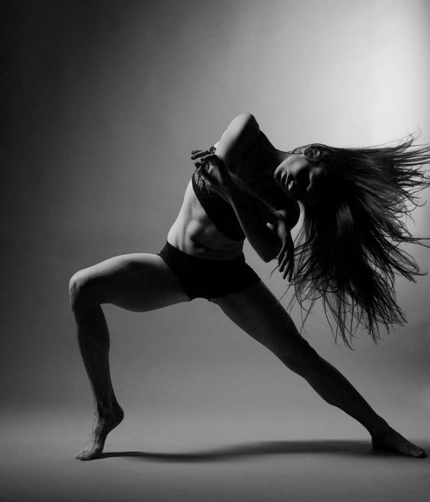
Uniform Requirements:
Our studio uniform is to be worn to ALL Dance & Gym classes.
When you dress like an athlete, you perform like an athlete.
Our branded mix and match apparel is available from our studio pro shop.

TINY TOES: Studio Tiny Toes Leotard, Pink leather Ballet shoes
BALLET: Studio Leotard, Pink ballet tights, studio shorts acceptable over leotard, pink leather Ballet shoes (NO baggy clothing)

SHOE’S REQUIRED FOR CLASS:
BALLET- Pink leather Ballet flats with elastic
JAZZ- Tan Jazz Shoes, Tiny’s Mini’s & Youth (Black for Junior, Tweens, Senior/Open students)
TAP- Tan Tap Shoes (Black for junior ,Teen/Senior/Open students)
CONTEMPORARY- No shoes
ACRO- No shoes
MUSICAL THEATRE- Tan Jazz shoes (Black chorus heels Senior/Open students)
HIP HOP- Converse type flat soled sand shoes
AERIAL SILKS- No shoes (long tights & t shirts are essential to this class
GYM – Clean white socks, Zone Active Singlet or T Shirt

Please ensure long hair is securely tied back and jewellery, watches including smart watches are left at home.

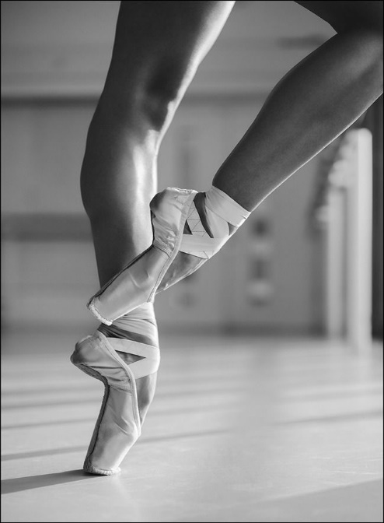

COMPETITION TROUPES:
Our competition booklet will be released in January. This will have information regarding all foreseeable costs and commitments for competition teams including competition dates, expected entry costs and uniform/costume requirements.

EXAM STUDENTS:
We offer and encourage all our Ballet, Jazz, Tap and acrobatic art students the opportunity to be part of our exam curriculum.
Exam Information will be released during Term 2. Exams are optional for all Jazz, Tap and Ballet students. Exams are held close to Term 3 holidays.

END OF YEAR CONCERT:
All Dance students performing in the end of year showcase will have extra rehearsals in the lead up to the annual showcase. 1 x studio rehearsals and 1 theatre dress rehearsal if available. The calendar for those dates will be released in March with the approximate cost for costumes and rehearsals. There is a concert levy of $25 payable in term 2.

CONTACT US
WEBSITE: www.zoneactivebaydance.com
EMAIL: hello@zoneactivebaydance.com
PHONE: 0419 842 449
FACEBOOK: https://www.facebook.com/zoneactivebaydance

